Test System
A typical rural distribution system with a peak load of 16.18 MVA. The maximum feeder capacity is 300 A.
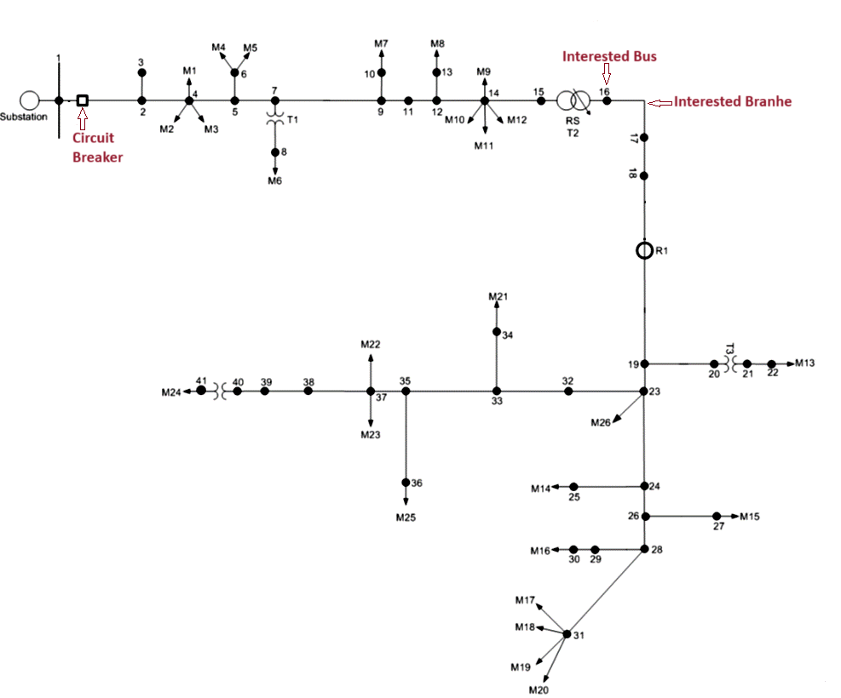
IBR Symbol

Loads
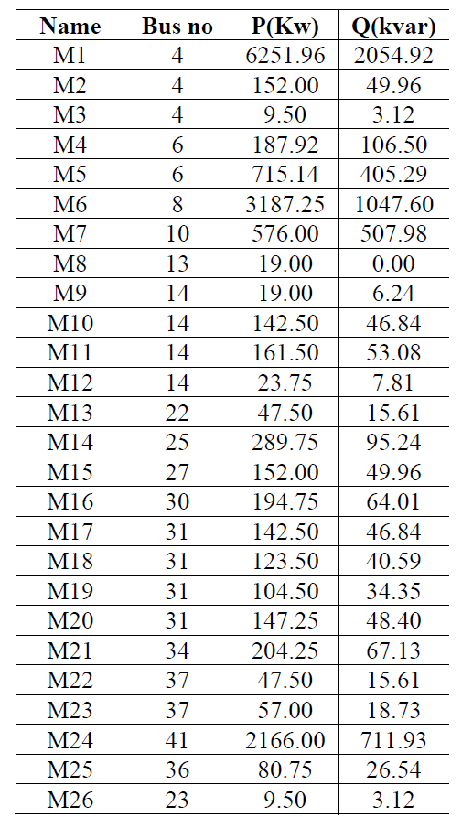

Lines
